Class :- TYIT Sem :- V Roll No. :- Date :- 21-09-26
Course Name :- Machine Learning Page no :-Practical Number :- 10
Aim: Apply the Support Vector Machine (SVM) algorithm on the given dataset.

Code:
import numpy as nm
import matplotlib.pyplot as mtp import pandas as pd

dataset = pd.read_csv('user_data.csv') x = dataset.iloc[:,[2,3]].values
y = dataset.iloc[:,4].values

#splitting the dataset into the training set and tesr set from sklearn.model_selection import train_test_split
x_train, x_test, y_train, y_test = train_test_split(x, y, test_size = 0.25, random_state = 0)

#feature scaling
from sklearn.preprocessing import StandardScaler sc = StandardScaler()
x_train = sc.fit_transform(x_train) x_test = sc.transform(x_test)
#fitting naive bayes to the training set from sklearn.svm import SVC
classifier = SVC(kernel='linear', random_state=0) classifier.fit(x_train, y_train)
#predicting the test set result. y_pred = classifier.predict(x_test)
#predicting the confusion matrix
from sklearn.metrics import confusion_matrix cm = confusion_matrix(y_test, y_pred)

#visualising the training set results
from matplotlib.colors import ListedColormap x_set, y_set = x_train, y_train
x1, x2 = nm.meshgrid( nm.arange(
start = x_set[:,0].min() - 1,
stop = x_set[:,0].max() + 1, step = 0.01
),
nm.arange(
start = x_set[:,1].min() - 1,
stop = x_set[:,1].max() + 1, step = 0.01
)
)

mtp.contourf( x1,
x2,

Class :- TYIT Sem :- V Roll No. :- Date :- 21-09-26
Course Name :- Machine Learning Page no :-
Practical Number :- 10
classifier.predict(
nm.array([x1.ravel(), x2.ravel()]).T).reshape(x1.shape), alpha = 0.75, cmap = ListedColormap(('yellow', 'green'))
)

mtp.xlim(x1.min(), x1.max())
mtp.ylim(x2.min(), x2.max())

for i, j in enumerate(nm.unique(y_set)): mtp.scatter(
x_set[y_set == j, 0], x_set[y_set == j, 1],
c = ListedColormap(('yellow', 'green'))(i), label = j)
mtp.title("ARYAN SVM Training set)") mtp.xlabel("Age")
mtp.ylabel("Estimated Salary") mtp.legend()
mtp.show()

#visualising the test set results
from matplotlib.colors import ListedColormap x_set, y_set = x_train, y_train
x1, x2 = nm.meshgrid( nm.arange(
start = x_set[:,0].min() - 1,
stop = x_set[:,0].max() + 1, step = 0.01
),
nm.arange(
start = x_set[:,1].min() - 1,
stop = x_set[:,1].max() + 1, step = 0.01
)
)
mtp.contourf( x1,
x2, classifier.predict(
nm.array([x1.ravel(), x2.ravel()]).T).reshape(x1.shape), alpha = 0.75, cmap = ListedColormap(('red', 'green'))
)

mtp.xlim(x1.min(), x1.max())
mtp.ylim(x2.min(), x2.max())

for i, j in enumerate(nm.unique(y_set)): mtp.scatter(
x_set[y_set == j, 0], x_set[y_set == j, 1],
c = ListedColormap(('white', 'green'))(i), label = j)

Class :- TYIT Sem :- V Roll No. :- Date :- 21-09-26
Course Name :- Machine Learning Page no :-Practical Number :- 10

mtp.title("ARYAN SVM (Test set)") mtp.xlabel("Age")
mtp.ylabel("Estimated Salary") mtp.legend()
mtp.show()


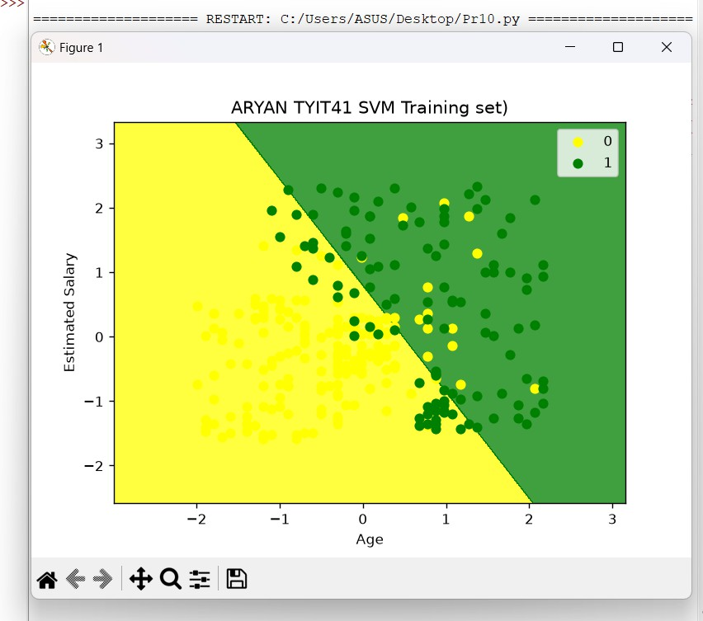

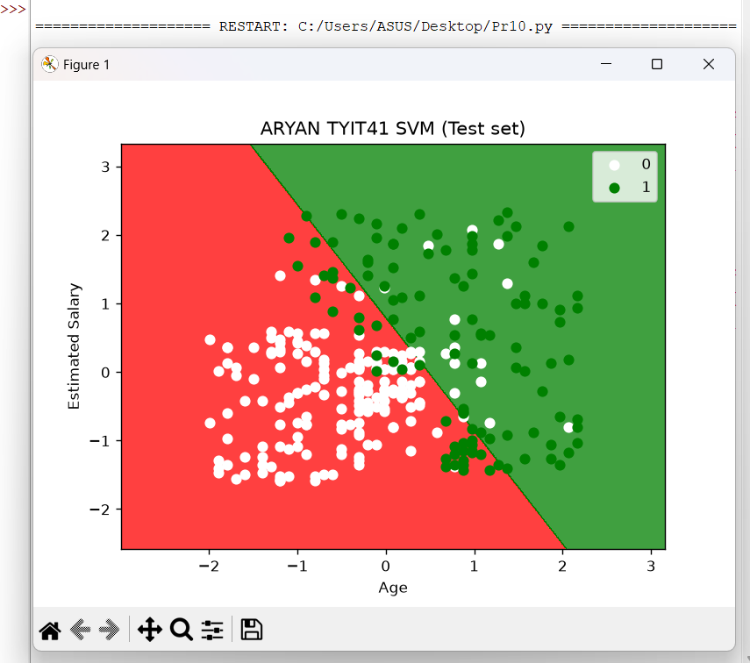
Output:

